General workflow for cmeAnalysis tracker

Note that this workflow hasn’t been fully optimized, so you should try a few tracking parameters and see what gives you the most accurate results. But in general it should perform the same function as Imaris, with similar accuracy, in a fraction of the time. I recommend analyzing entire cells, or at least 200-500 pixel movies. Some of these slides are from Marcel from the Schmid lab. For more details look at “cmeAnalysis_workflow.ppt” on this computer.

1. Organize your folders so that each movie is inside a folder called “cell1_2s” , “cell2_2s” etc. note there are no spaces in the folder name. The overall structure should be “yourfiles/ cell1_2s/ GFP/ moviechannel1.tif” and “yourfiles/ cell1_2s/ RFP/ moviechannel2.tif”
   1. You should be able to do this automatically by running “makeCMEanalysisFolders_Bulk_twocolor.m”
   2. If that doesn’t work: try putting all your GFP movies from a single condition in one folder, and run “makeCMEanalysisFoldersBulk.m” for that folder. Repeat for each color and each condition.
   3. If that doesn’t work either, you can sort each movie to its own folder for individual analysis by putting all your movies in one folder and then using “makeCMEanalysisFolders.m”
2. Open Matlab 2013a.
3. Open ‘runCMEanalysis.m’ (it’s in Documents/ MATLAB)
4. Set the gap size and search radius limits
   1. You can try the parameters you were using in Imaris. Ideally you should try a few gap sizes and tracking radii. Currently we’re using gap size 3 frames, tracking radius between 0 and 2.3 pixels (250 nm) for our movies
5. Click “run”
6. 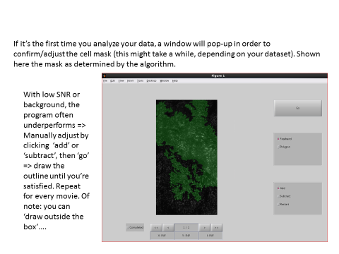
7. 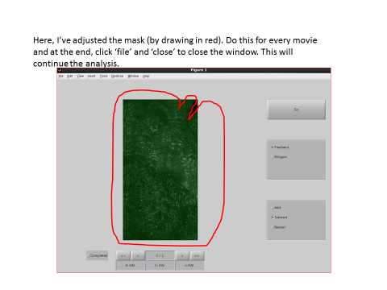
8. When the window “Choose condition folder” pops up, select the top folder (the folder above “cell1_2s”, i.e. “yourfiles” in the example above)
9. The program may or may not give an error, but it was successful for our purposes if the folder containing your movies now contains folders called “detection” and “tracking.”
   1. If the “tracking” folder was created for only one channel (e.g. RFP) then run the analysis again for the other channel.
10. Want to visually check the accuracy of your tracking? Go to step 14 first
11. Open Matlab 2015b
12. Open “extractXYcoordinates_20161003.m”
    1. For speed, set

makefigs = false;

saveallgraphs = false;

1. For each movie, the program will ask you to select the “trackedfeatures.mat” file, which is in the “tracking” folder in the same location as your movie.
2. After the program is finished, a “position.csv” file will be saved in the same “tracking” folder, which you can use as an input for Sun Hong’s ‘Associate_tracks.m’ program. That’s it!

Advanced

You can clear away short tracks (assuming they are noise) and tracks that jump erratically in intensity.

Before you run “extractXYcoordinates.m,” change these values in the first few lines of the program:

* 1. To clear away short tracks, set “cutLifetimes = true” and set the value for “lifetimesCutoff” (in frames). E.g. a setting of “3” will throw away tracks that are 1 or 2 frames long.
  2. To clear away erratic tracks, set “rejectErraticTracks = true”. This code was written by Josh Ferguson in the Kural lab at OSU. It keeps tracks with “smooth” intensity change (across any four frame window in the track) and rejects the rest.

1. To visually check how accurate your tracking was, for the parameters you used:

* In Matlab 2013a run ‘runCMEviewer.m’
* Within the cmeViewer, try toggling viewing Detections, Tracks; display by Lifetime (we don’t currently agree with the creators on the biological significance of ‘categories’); Select Track; Generate Montage; Print Figures.
* I modified Generate Montage so that you can decide how many montages to make at once so you get a sense of how accurate the tracker was. (check ‘show detection’ before you Generate Montage). You can then save those montages with Print Figures.

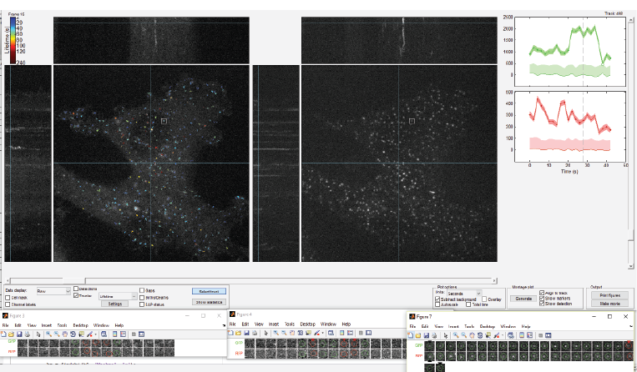

* Note that the post-processing steps (after tracking and before plotting) differ a bit between Sun’s program and this one; but this gives you a general sense of how the tracker is doing.